DOCKER AND KUBERNETES

- Docker is a company which provides a set of tools for building and sharing container images, and running containers at both small and large scale.
- Kubernetes is a tool which manages (“orchestrates”) container-based applications running on a cluster of servers.
- You can use Docker without Kubernetes… and you can use Kubernetes without Docker.

DOCKER :
Docker is a company that makes a set of open source tools for using containers as a way to package and run applications.
Features and tools :
- docker engine :
main docker command line tool which run and create container
- Docker file :
a language for building container images
- Docker hub :
online registry for publishing and sharing container images
- Docker Compose :
to share container setup instaructions
- Docker Swarm mode :
to manage containers running on multiple servers.
Things to do with docker :
Create container images
run your own conatiner images
share images with coworkers
share images on the internet
Run third party containers
Run multi container applications
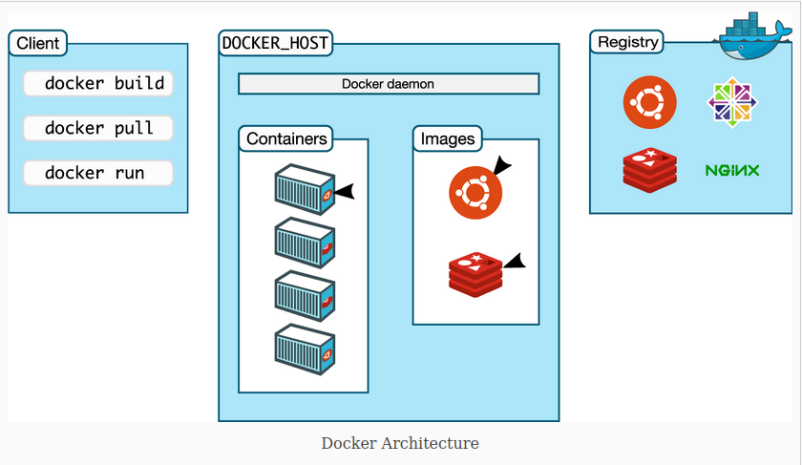
Architectural understanding :
Developers will typically interact with Docker through a command line interface (CLI) to communicate with the Docker client to run commands like docker build or docker run. These are translated as API commands to the Docker daemon
, which directs the system to build the environment.
A Docker registry stores Docker images, which are executable templates.
Thus, Docker containers are essentially instances of these images.
Docker Hub is a large public registry full of many helpful, pre-written container images.

KUBERNETES :
Kubernetes is server-side software for managing containers.

Kubernetes is like a robot that runs docker run on dozens, or hundreds, of servers.

Kubernetes turns a set of servers into a complete, private cloud.

It is used to automate all of the time consuming tasks such as , creating container and placing them to server , configuring container , checking container health , and managing access to resouces , like memory and CPU. , it falls into a category of CONTAINER ORCHESTRATION TOOLS.

It is also abbreaviated a K8s.
It choose the placement of containers to optimize computing resources ,”orchestarting” where these workloads end up,

Docker Swarm mode, Hashicorp Nomad, Apache Mesos and AWS’s Elastic Container Service are all container orchestration tools and are alternatives to Kubernetes.

Features :
Container scheduling
Container management
Auto-scaling containers
Networking
Storage
Logs and monitoring
Security

Things to do with kubernetes :
deploy our own container based applications
deploy third party container based applications such as DB and web application
connect your apps to each other
upgrade applications
Gather metrics

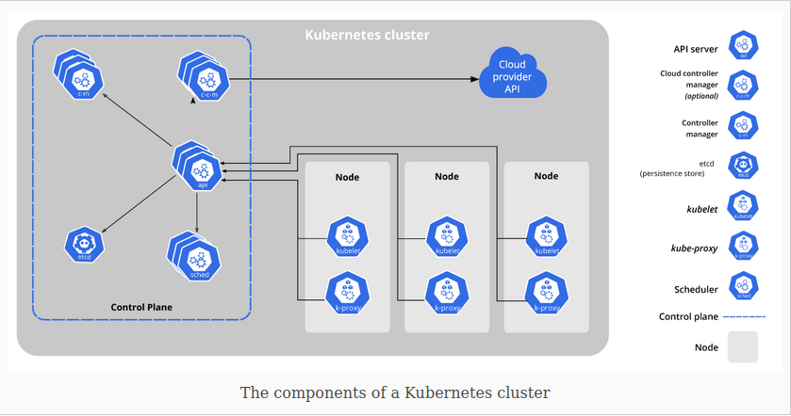
Architectural understanding :
- All Kubernetes deployments have at least one cluster.
- A cluster contains nodes.
- These nodes host pods.
- These pods include a running set of containers.
- A Kubernetes instance has a control plane to manage all these components.

There are many other important K8s components at work here—they include kubectl, the CLI for managing Kubernetes clusters, kube-scheduler, which manages availability and performance and kubelet, the main agent that runs on each pod.
Kubernetes can be installed on Linux, macOS or Windows, or accessed through a web UI or REST API.

STEPS TO INSTALL KUBERNETES
1) Install docker
sudo apt-get update
sudo apt-get install docker.io
docker –-version
2) Start and enable Docker
sudo systemctl enable docker
sudo systemctl status docker
sudo systemctl start docker
3) Add kubernetes signing key
curl -s https://packages.cloud.google.com/apt/doc/apt-key.gpg | sudo apt-key add

Note : sudo apt-get install curl(if curl is not installed)
4) Add software repositories
sudo apt-add-repository "deb http://apt.kubernetes.io/ kubernetes-xenial main"
5) Kubernetes installation tools
Install Kubernetes tools with the command:
sudo apt-get install kubeadm kubelet kubectl
sudo apt-mark hold kubeadm kubelet kubectl
Verify the installation with:
kubeadm version
6) Begin kuberenetes Deployment
sudo swapoff –a (used to disable swap memory)
7) Assign unique hostname for each server node
sudo hostnamectl set-hostname master-node
sudo hostnamectl set-hostname worker01
8) Iniatilize Kubernetes on Master node
Switch to the master server node, and enter the following:
sudo kubeadm init –pod-network-cidr=10.244.0.0/16
Note : make a note of the output starting with , kubeadm join
Create a directory for cluster:
kubernetes-master:~$ mkdir -p $HOME/.kube
kubernetes-master:~$ sudo cp -i /etc/kubernetes/admin.conf $HOME/.kube/config
kubernetes-master:~$ sudo chown $(id -u):$(id -g) $HOME/.kube/config
9) Deploy Pod network to cluster
A Pod Network is a way to allow communication between different nodes in the cluster.
sudo kubectl apply -f https://raw.githubusercontent.com/coreos/flannel/master/Documentation/kube-flannel.yml
kubectl get pods –all-namespaces (to verify everything is running perfectly or not)
10) Join Worker node to cluster
Switch to the worker01 system and enter the command you noted from Step 8:
kubeadm join --discovery-token abcdef.1234567890abcdef --discovery-token-ca-cert-hash sha256:1234..cdef 1.2.3.4:6443

Switch to the master server, and enter:
kubectl get nodes (to get to display all the nodes)

DIFFERENCE BETWEEN DOCKER AND KUBERNETES

